|  |  |  |  |  |  |  |  |  |  |  |  |  |  |  |  |  |  |  |
| --- | --- | --- | --- | --- | --- | --- | --- | --- | --- | --- | --- | --- | --- | --- | --- | --- | --- | --- |
| **INTERSTATE CONTAINER CORPORATION** | | ***Date:* 08/23/2016** | ***Spec #:*** | | | | | | | | | | ***Design #:*** | | **160812-02** |  |  |  |
|  |  |
| ***Customer:* DeMet's Candy** |  |  |  |  |  |  |  |  |  |  |  |  |  |  |  |  |  |  |
|  |  |  |  |  |  |  |  |  |  |  |  |  | ***Cut*** | **160 in.** | |  |  |
|  |  |  |  |  |  |  |  |  |  |  |  |  |  |  |
| ***Description:* Shipper-441 CVS 8/4.7 oz Stand Up Bag** | |  |  |  |  |  |  |  |  |  |  |  |  |  |  |
|  |  |  |  |  |  |  |  |  |  |  |  | ***Crease*** | **100 in.** | |  |  |
|  |  |  |  |  |  |  |  |  |  |  |  |  |  |
| ***Style:* HSC** | ***Revision Info:* [0] 07/01/2016:** |  |  |  |  |  |  |  |  |  |  |  |  |  |  |
|  |  |  |  |  |  |  |  |  |  |  |  |  |  |  |  |  |
|  |  |  |  |  |  |  |  |  |  |  |  |  |  |  |  |  |
| ***I.D. :* 8+13/16 x 8+13/16 x 7+1/2** | ***Blank size:* 16+1/2 x 37** |  |  |  |  |  |  |  |  |  |  |  |  |  |  |  |  |  |
|  |  |  |  |  |  |  |  |  |  |  |  |  |  |  |  |  |
| ***Board:* 44 B K** | ***Combination:* 42 - 36M - 42** | ***Designer:* Alan Groff** |  |  |  |  |  |  |  |  |  |  |  |  |  |  |  |  |
|  |  |  |  |  |  |  |  |  |  |  |  |  |  |  |  |

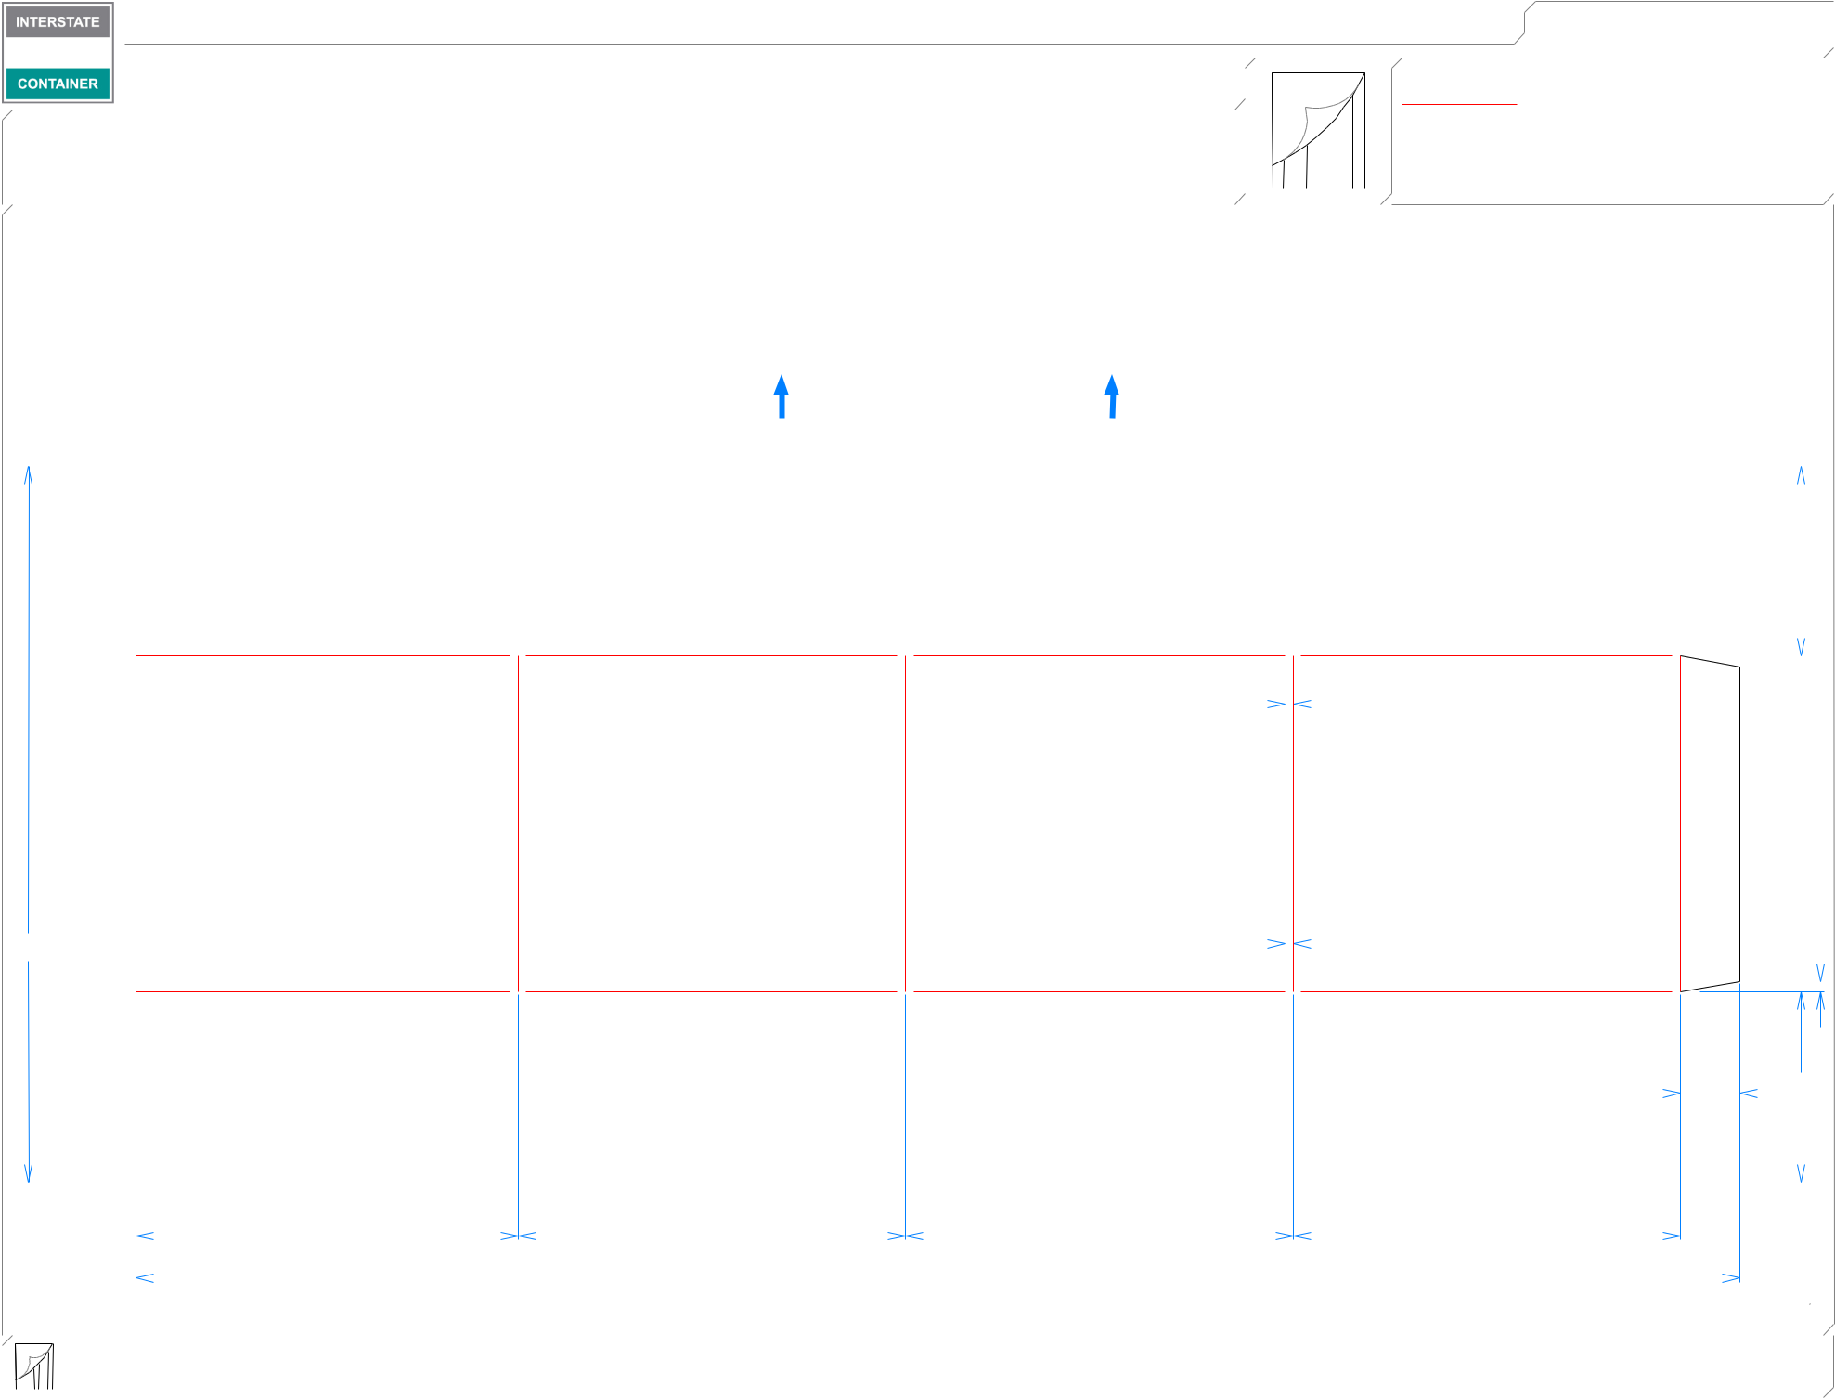

1. **OUT MINI FFG**

**LEAD EDGE**

|  |  |  |  |  |  |  |  |  |  |  |  |  |  |  |  |
| --- | --- | --- | --- | --- | --- | --- | --- | --- | --- | --- | --- | --- | --- | --- | --- |
|  |  |  |  |  |  |  |  |  |  |  |  |  |  |  |  |
| 43*/*8 | |  |  |  |  |  |  |  |  | 43*/*8 | | | | | |
|  |  |  |  |  |  |  |  |  |  |  |  |  |  |  |  |



|  |  |  |  |  |  |  |  |  |  |
| --- | --- | --- | --- | --- | --- | --- | --- | --- | --- |
|  | 3*/*16 |  |  |  |  |  |  |  |  |
|  |  |  |  |  |  |  |  |  |
|  | 73*/*4 |  |  |  |  |  |  |  |  |
| 161*/*2 | 3*/*16 |  |  |  | 1*/*4 | | | |  |
|  |  |  |  |  |  |  |  |
|  |  |  |  |  |  |  |  |  |  |



|  |  |  |  |  |  |  |  |  |  |  |  |  |  |  |  |  |  |  |
| --- | --- | --- | --- | --- | --- | --- | --- | --- | --- | --- | --- | --- | --- | --- | --- | --- | --- | --- |
|  |  |  |  |  |  |  |  |  |  |  |  |  |  |  |  |  |  |  |
| 43*/*8 | |  |  |  |  |  |  |  |  |  |  |  | 13*/*8 |  | 43*/*8 | | |  |
|  |  |  |  |  |
|  |  |  |  |  |
|  |  |  |  |  |  |  |  |  |  |  |  |  |  |  |  |  |  |  |



|  |  |  |  |  |  |  |  |  |  |  |
| --- | --- | --- | --- | --- | --- | --- | --- | --- | --- | --- |
|  | 813*/*16 |  | 815*/*16 |  |  |  | 815*/*16 |  | 815*/*16 |  |
|  |  |  | 37 |  |  |  |
|  |  |  |  |  |  |  |  |  |  |
|  |  |  |  |  |  |  |  |  |  |

|  |  |  |  |  |  |  |  |  |  |  |  |
| --- | --- | --- | --- | --- | --- | --- | --- | --- | --- | --- | --- |
|  |  |  |  |  |  |  |  |  |  |  |  |
|  |  |  |  |  | **inside view** | | ***notes:*** |  |  |  |  |
|  |  |  |  |  |  |  |  |  |
|  |  |  |  |  | **Vertical Corrugation** | | ***Qty/unit:* 1** | ***Area - waste:* 4.07 sq. ft** | ***Waste on blank:* 3.9%** | ***Piece weight - waste:* 0.55 lbs./248.61 g** |  |
|  |  |  |  |  |  |
|  |  |  |  |  |  |

